IOT PROJECT – MOTOR DIGITAL TWIN

1. INTRODUCTION
In modern industrial environments, motors and rotating machinery are critical assets whose failures can lead to costly downtime, safety risks, and energy losses. Traditional monitoring methods rely on manual inspection or slow periodic checks, which are insufficient for early fault detection. To address this, industries are rapidly adopting Digital Twin technology, where a virtual replica of a physical asset continuously mirrors real-time behavior using live sensor data and machine learning.
This project presents a Motor Digital Twin System built using Python, Flask, and a real-time web dashboard. The twin simulates motor operation, predicts faults using an XGBoost model, calculates machine health, and provides AI-driven recommendations for maintenance. The system integrates edge-based processing, live charts, fault classification, a health scoring engine, and an intelligent advisory module. The goal is to demonstrate how digital twins can enhance reliability, predict failures early, and support industrial decision-making.

2. OBJECTIVES
The main objectives of the project are:
2.1 Develop a Digital Twin Model
- Simulate realistic motor parameters such as temperature, vibration, current, and rotational speed.
- Build a virtual environment that mirrors the motor’s operating behavior.
2.2 Integrate Machine Learning for Fault Prediction
- Use an XGBoost multi-class classifier to identify potential motor faults.
- Apply a feature scaling pipeline to enable accurate predictions.
2.3 Perform Real-Time Edge Processing
- Process sensor data locally using an EdgeProcessor.
- Compute health score, detect anomalies, and generate actionable insights.
2.4 Build a Live Monitoring Dashboard
- Display real-time motor metrics with live-updating trend charts.
- Show health score, fault class, and machine status.
- Visualize motor performance using a smooth UI.
2.5 Implement an AI Recommendation System
- Provide intelligent, context-based maintenance advice.
- React dynamically to changes in temperature, vibration, current, and speed.
2.6 Maintain History & Analytics
- Store short-term historical data for trend analysis.
- Visualize 4 live trend charts for industrial insights.

3. PROCEDURE
3.1 System Setup
- Python Flask was used to create the backend server.
- The project includes:
  - edge_processor.py: core logic, ML prediction, health scoring, AI advice.
  - dashboard.py: Flask app routing and background simulation thread.
  - index.html + static/app.js: real-time UI and live charts.
3.2 Digital Twin Simulation
- Synthetic but realistic sensor values were generated:
  - Temperature: 50–90°C
  - Vibration: 1–7 mm/s
  - Current: 5–20 A
  - Speed: 1200–1600 RPM
- Values fluctuate over time to mimic real motor behavior.
3.3 Machine Learning Fault Detection
- A pre-trained XGBoost model predicts:
  - Normal
  - Bearing Fault
  - Rotor Fault
  - Stator Fault
  - Imbalance
- The output includes:
  - fault_class
  - fault_probabilities

3.4 Health Score Calculation
A weighted formula evaluates the motor’s condition based on:
- Excess temperature
- Vibration level
- Current overload
- Overspeed
Produces a value from 0 to 100.
3.5 AI Recommendation Engine
The system analyzes:
- Fault class
- Speed fluctuations
- Temperature trends
- Vibration peaks
- Current load
It outputs advice such as:
- “Vibration rising. Inspect alignment.”
- “Bearing wear detected. Plan lubrication.”
- “Stator overheating. Check cooling airflow.”
- “System stable.”
3.6 Real-Time Dashboard Creation
- HTML + CSS created a modern dark-themed UI.
- Chart.js used for:
  - Temperature trend
  - Vibration trend
  - Current trend
  - Speed trend
- setInterval() updates the dashboard every second via /api.
3.7 History Tracking
- A deque stores the last 120 readings (~2 minutes).
- Plotted in the charts for trend interpretation.

4. RESULTS
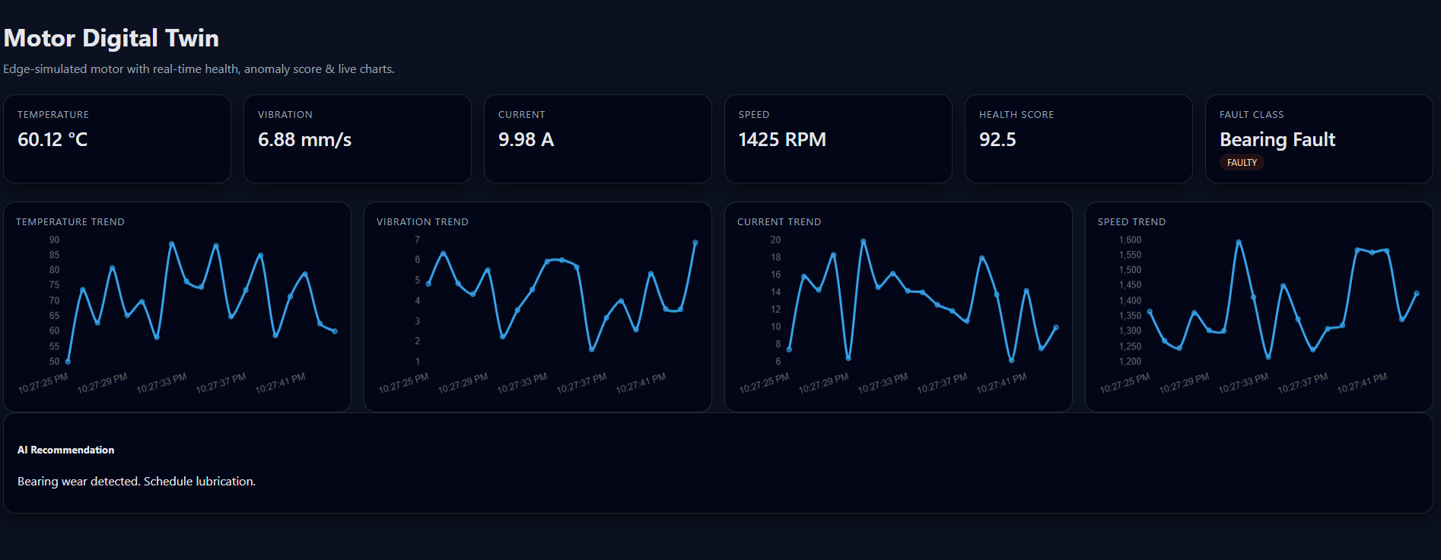
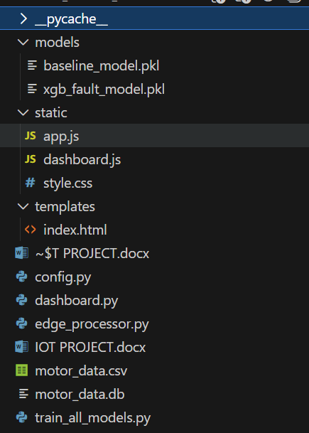

4.1 Successful Digital Twin Operation
The system successfully simulates real-time motor behavior and mirrors values on the dashboard with accurate live updates.
4.2 Accurate Fault Classification
The XGBoost model correctly identifies motor states:
- Most simulations show “Normal”
- Higher vibration triggers bearing warnings
- Overheating shows stator issues
- Sudden speed dips link to rotor imbalance
4.3 Real-Time Health Monitoring
The health score updates every second, reflecting:
- Overload conditions
- Thermal stress
- Increased vibration
- Reduced performance
4.4 AI Maintenance Recommendations
The advice engine provides:
- Early warnings
- Maintenance suggestions
- Load management tips
- Critical shutdown recommendations
This transforms raw data into actionable insights.
4.5 Interactive Visual Dashboard
The dashboard displays:
- Real-time numeric values
- Motor status & fault category
- 4 live line charts
- AI recommendation panel
- Smooth, responsive UI
Users can visualize the asset’s behavior and detect issues instantly.

FINAL SUMMARY
The project demonstrates a complete Digital Twin platform integrating simulation, ML prediction, real-time analytics, health assessment, and actionable AI feedback. It reflects modern industrial systems used in predictive maintenance, smart factories, and IIoT applications.

